**EGRE 364 – Microcomputer System**

**Laboratory Number 8**

**Sensor Interfacing**

**Lab Section: Tuesday 1PM**

***Lab conducted on: November 26th , 2019***

***Report Submitted on: December 9th , 2018***

**Papa Beye & Omar Amr**

**Major: CPE & CPE**

**Introduction**

The purpose of this lab was to utilize the use the ADC modules, LCD driver, GPIO pins to interface with the distance and reflectance sensor and gathered data and display the data on the LCD display using C language in the Keil µVision software development environment. To achieve this objective, we used GPIO registers, provided LCD driver & ADC initialization, internal ADC conversion, LCD pin configuration, and GPIO interfacing. The main objective was to utilize the given ADC and LCD library to gather the analog signal from distance sensor and convert it into a distance in cm and use GPIO I/O line manipulation to detect low or high reflectance from the reflectance sensor. We used the provided LCD driver to display a string to the LCD display and use the provided LCD bars to indicate a scaled ratio between the distance sensor’s operating range from 10 cm – 50 cm. We reported the sensor values of “B” or “W” for each sensor to the LCD display, along with the current distance and the appropriate distance bars. The distance work by outputting an analog voltage signal proportional to the distance it detects. We can read the analog signal to the ADC to convert it to a value, since we were using a 12-bit length and $V_{ref}=5V$, we could get the read input voltage from the distance, as seen below in the equation. Once we determine the $V_{in}$, we could use the line of best fit function determined experimentally to find the distance, as seen below. For the reflectance sensor, since these are digital I/O sensors, we created a routine that would set the I/O line to output and set high and allow for the capacitor to charge using a delay; then we set GPIO pin to an input and measured the length of time that capacitor needed to discharge thus allowing us to determine if it detected “black” or “white” by compare the length of time to the given threshold. The LCD driver and functions “LCDDisplay_String” and “LCDDisplay_char” allowed us to display strings, which included the distance in cm and the “W” or “B”. The LCD display that we used an LCD 4x24 segments, 4 commons, multiplexed 1/4 duty, 1/3 bias. The configuration, setup, and C function used in this lab can be seen below. We implemented a delay function to be able to smoothly gather and process data and to be able to detect a change in the reflectance sensor. In this lab, we used the practiced methods and material that we learned in class about LCD, ADC, and sensor detection.

**Functionality and Correctness**

The STM32L4 discovery board has many GPIO ports but we used two for the distance sensor and the two reflectance sensors. In order to interface and gather data from the distance sensor and reflectance sensors, we had to utilize the given library of ADC, LCD Driver, and Sensor configuration jointly to be able design functions for the sensors. We learned that to correctly use the distance sensor, we had to initialize the GPIO port A pin to connect to the ADC, start the conversion through software, wait for the result and read the translated result from the ADC_DR (Data Register). Using the formulas below, we calculate the distance from the two equations and displayed the distance(int) onto the LCD display. Next, for the reflectance sensor, we had to follow the procedure detail below; the reflectance sensor was designed to interface with a digital I/O line to charge the capacitor and observe the length of time it takes to discharge thus allowing us to determine the reflectance value. To create the read reflectance sensor function, we manipulated GPIO configurations and initialize the GPIO port E to use for both reflectance sensors. In order to set the LCD display to display “W” or “B” for each sensor we used the provided function “LCDDisplay_String” function. The provided functions used the LCD pins by manipulating the values of the LCDRAM[] array. Lastly, we were able to complete the lab by utilizing the given ADC, GPIO, & LCD driver libraries.

**Equation for ADC Result and $V_{in}$**

$$ADC Result =\frac{V_{in}}{V_{ref}} × 4096$$

$$V_{in}=\frac{ADC Result}{4096}*V_{ref}$$

**Experimentally found Voltage at numerous distances to produce a linear line of best fit**

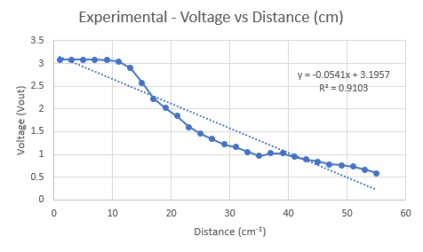

**Using experimental data, found inverse distance and found line of best fit, used in code to determine distance using the input analog voltage converted to digital through ADC**

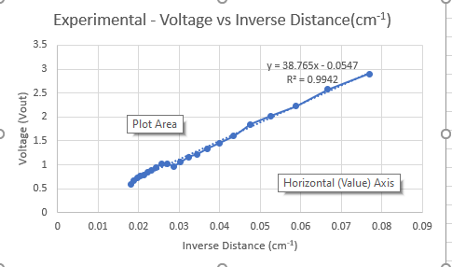

**Detailed code of Read Distance function**

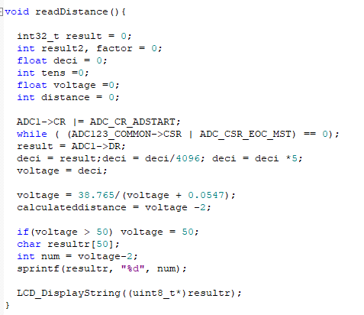

**Pseudo Code/routine to determine if reflectance detects White or Black**

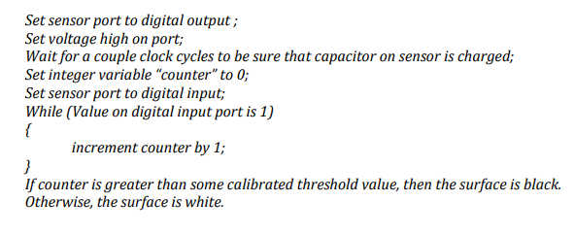

**Diagram of Polulu Reflectance Sensor**

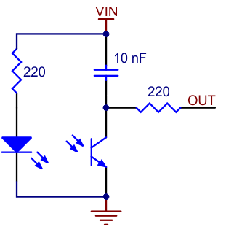

**Sequence used to determine using I/O lines**

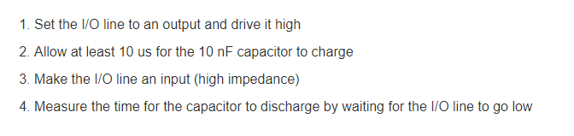

**Detailed code of Read Reflectance function**

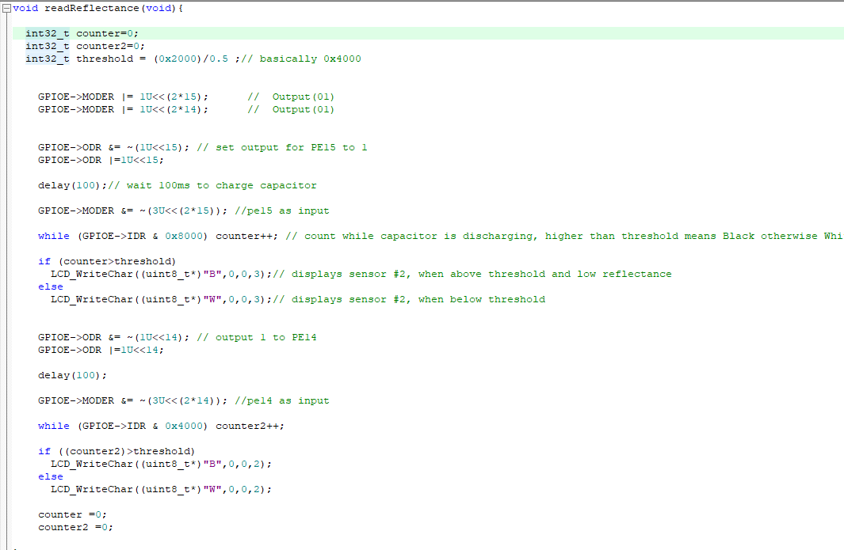

**Bars Function used to turn on LCD Bars based on global distance determined from distance sensor**

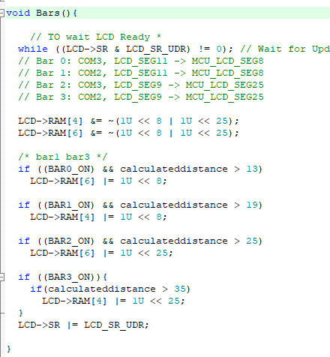

**LCD Pin configuration of Multiplexed Drive of STM32L Board**

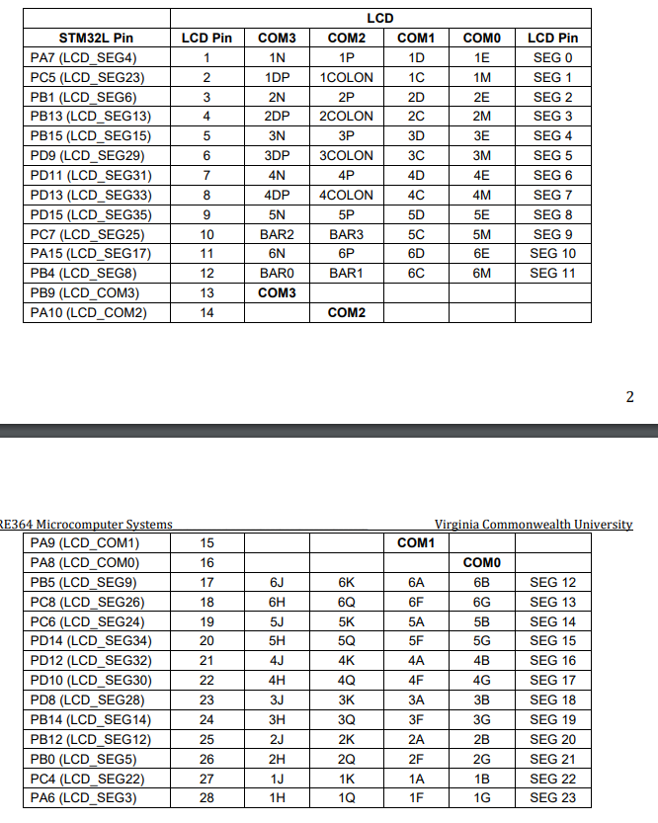

**Pre-Lab and Demo**

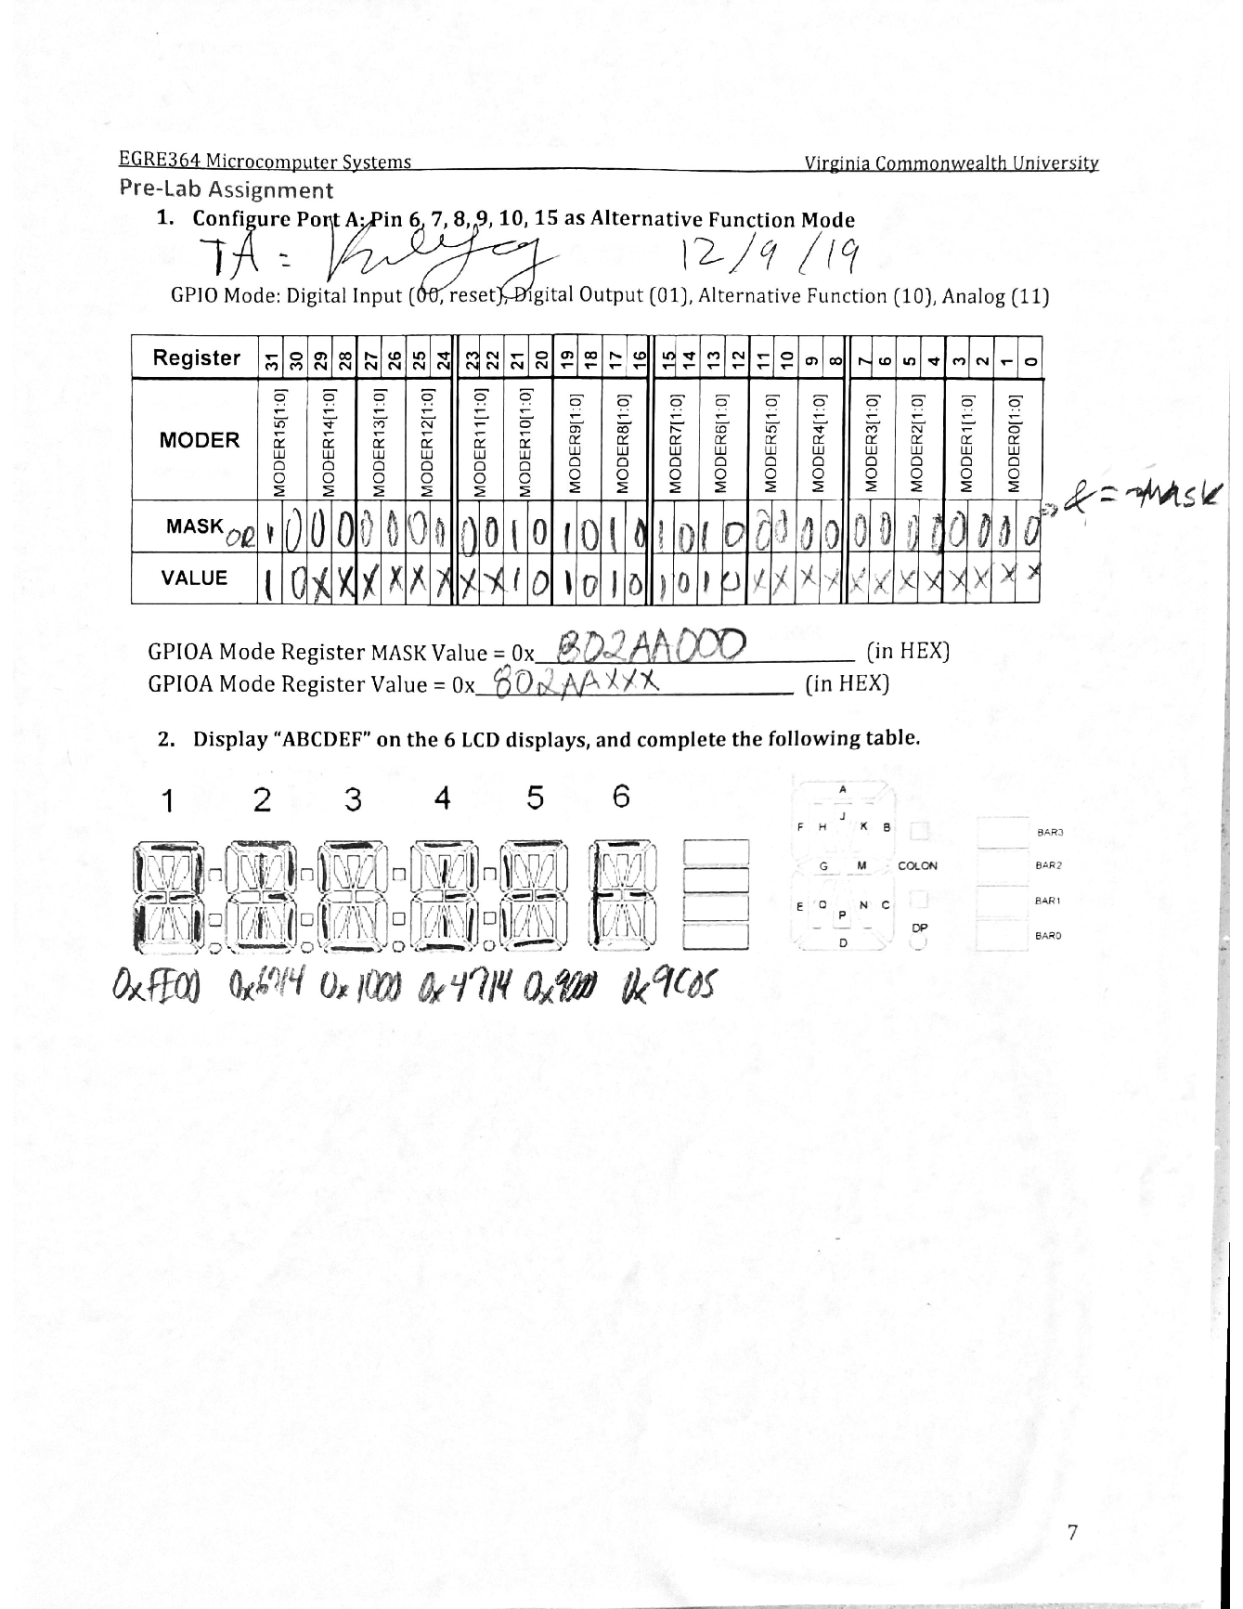

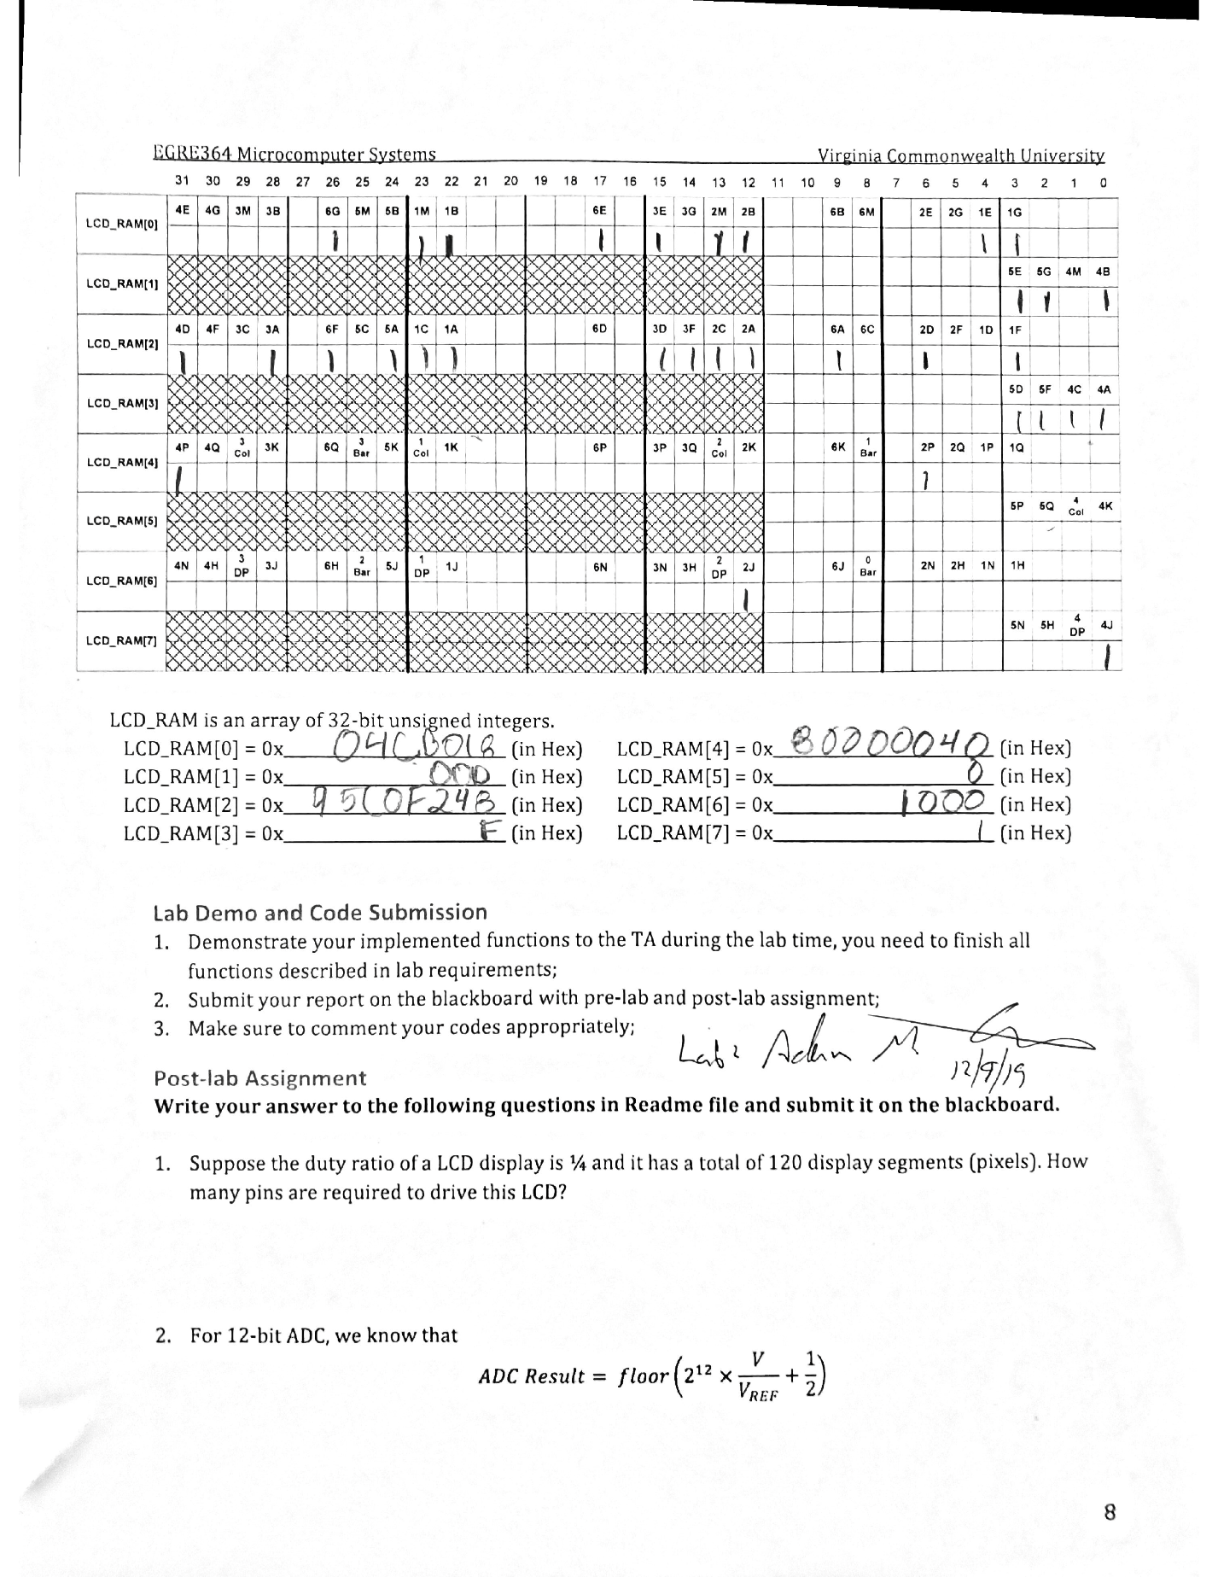

**Post-Lab**

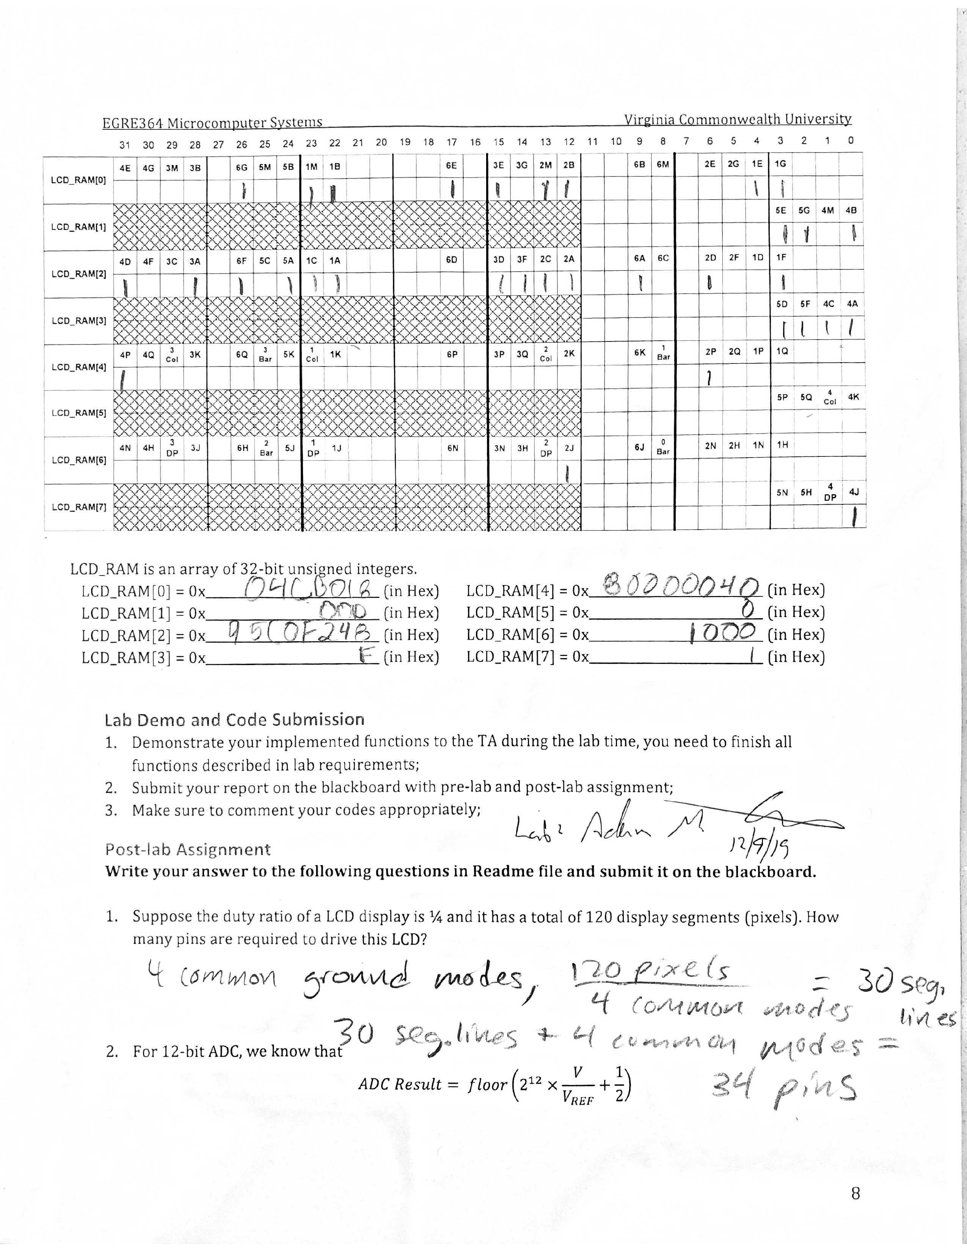

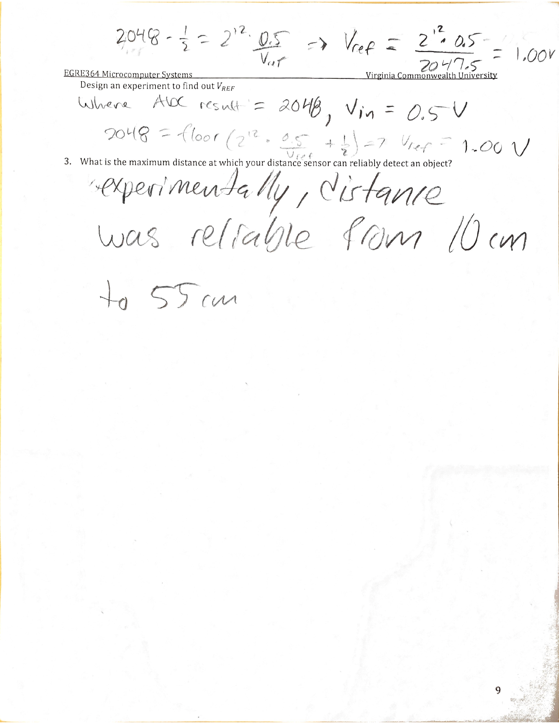

**Conclusion**

In this lab, we became more comfortable with interfacing and collecting data from sensors and displaying on the LCD display on our MCU. We were able to understand concepts of the LCD driver, ADC conversions, and interfacing with sensors to complete our objective. In this lab, we gathered data from the distance sensor and two reflectance sensors to display the gathered and process data to the LCD display, along with the proportional bars. We were able to achieve the objective of by utilizing the provided libraries of the ADC, LCD and GPIO initializations and drivers. We used previous knowledge of interfacing with I/O lines and used knowledge from lecture about the LCD display and ADC conversion. We were able to apply concepts of the ADC, such as the software triggers and resolution and overall ADC result calculations. We learned a lot and gained more experience about how to use sensors and how they interface with the STM32L4 board and LCD displays & ADCs. We didn’t face any issues but there was a learning curve that allowed us to learn and understand how to utilize libraries and concepts from lecture and interface with sensors in our lab to properly complete our objective.